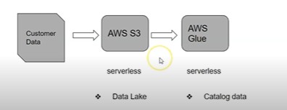

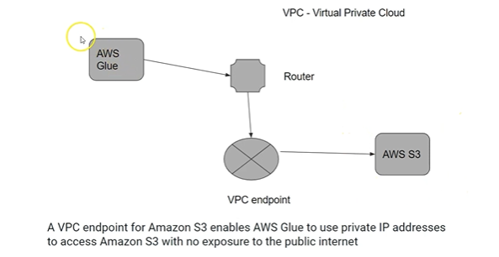

**Querying data using Amazon Athena**

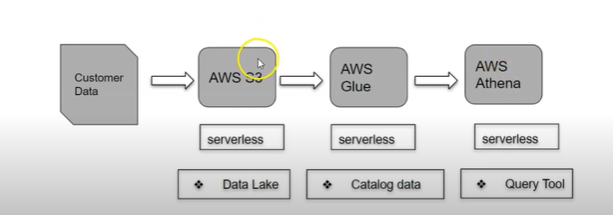

AWS Athena uses glue catlog to query the data

# Running Spark transformation jobs using AWS Glue

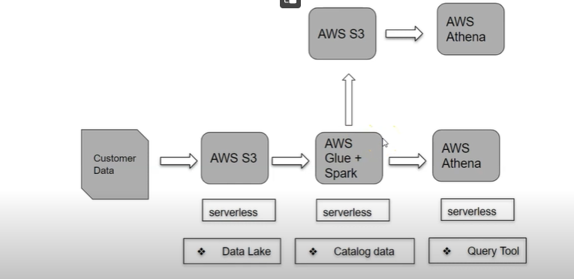

Data transformation using spark on AWS Glue.

# An automated data pipeline using Lambda, S3 and Glue

